Table of Contents
Table of Contents 1
OSPF 2
Lab 001 Single Domain 3
Lab 002 Stubbiness 5
Lab 003 Redistribution 8
Lab 004 Multiple OSPF Domains 11
Lab 005 Multi AS 13
Lab 006 Virtual Link 15
Lab 007 OSPF Interface Type 17
Lab 008 OSPF Multi Area Adj 19
Lab 009 OSPFv3 22
Lab 010 OSPFv3 Virtual Link 24
Lab 011 Area-Range Summarization 26
Lab 012 Metric Preference 28
Lab 013 Overload, SPF & LSA Flooding 29
Lab 014 Authentication 34
Lab 015 Timer 36
Lab 016 BFD 38
Lab 017 Graceful Restart 40
Lab 018 LFA Link Protection 43

OSPF

Lab 001 Single Domain
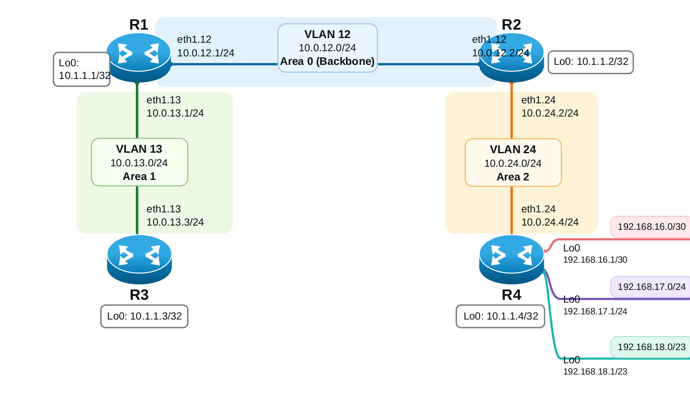
Figure 0-1 OSPF Single Domain

Load Config
# r1,r2,r3,r4
conf
load override /lab-configs/ospf.basic.conf
commit

Task 1
- Configure a unique, stable router ID on R1 and R2 using their loopback IPs.
- Enable OSPF Area 0 on the R1-R2 link.
- Set R1's priority on the Area 0 Ethernet link to 255 and R2's priority to 100, then commit the configuration.
- Keep both loopbacks advertised in Area 0 but prevent OSPF adjacency attempts on loopback interfaces by configuring them as passive.
- Verify the neighbor state, router IDs, interface, and DR/BDR roles.

Task 2
- Configure the router IDs on R3 and R4.
- Add R1-R3 to Area 1 and R2-R4 to Area 2.
- Force these router-to-router links to OSPF point-to-point network type.
- Configure the loopback on R3 as passive in Area 1 and the loopback on R4 as passive in Area 2.
- Configure the three R4 interfaces facing ep16, ep17, and ep18 as passive OSPF interfaces in Area 2. Do not create OSPF adjacencies with the hosts.
- Verify the neighbors and the OSPF interface types on all routers.

Task 3
- Before applying summarization, record how R1 and R3 learn these routes:
192.168.16.0/30
192.168.17.0/24
192.168.18.0/23
- On R2, configure an Area 2 summarization that covers those three prefixes using 192.168.16.0/21.
- Verify the summary route in R1's routing table and Area 0 LSDB.
- Verify the effect in R3's routing table as well.
- Confirm that the three more-specific routes are no longer individually advertised from Area 2 into Area 0, while the summary route is present.
- Verify traffic/reachability to all three endpoint networks after the change.

Lab 002 Stubbiness
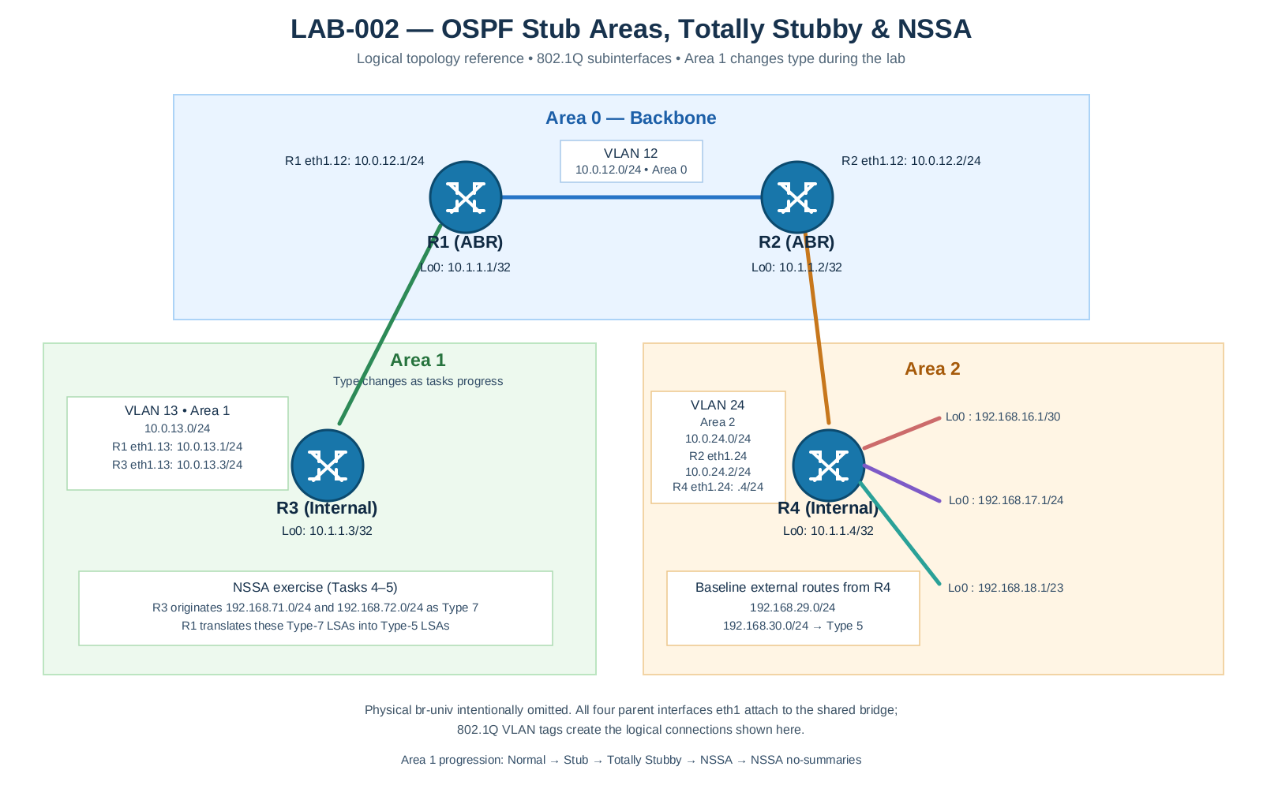

Load Config
# r1,r2,r3,r4
conf
load override /lab-configs/ospf.multiarea.conf
commit

Task 1
- On R4, configure static discard routes 192.168.29.0/24 and 192.168.30.0/24.
- Create a policy matching protocol static and apply it under protocols ospf export.
- Verify adjacencies, route tables, OSPF route path types, and LSDBs.

Task 2
- Configure Area 1 as stub on both R1 and R3.
- On the ABR R1, configure a default metric of 5 for the stub area.
- Do not configure no-summaries yet.
- Verify neighbor adjacency, area type, route table, and Area 1 LSDB.
Acceptance criteria:
- R1 and R3 remain Full neighbors.
- R3 no longer learns R4's Type-5 external routes 192.168.29.0/24 and 192.168.30.0/24 into Area 1.
- R3 can still learn inter-area Type-3 summary routes from the rest of OSPF.
- R3 has a default route originated by R1 with the configured metric behavior.
# r3 (area 1)
root@r3# run show ospf database external
OSPF AS SCOPE link state database
Type ID Adv Rtr Seq Age Opt Cksum Len
Extern 192.168.29.0 10.1.1.4 0x80000001 724 0x22 0x8d8e 36
Extern 192.168.30.0 10.1.1.4 0x80000001 724 0x22 0x8298 36

root@r3# run show ospf neighbor detail
Address Interface State ID Pri Dead
10.0.13.1 eth1.13 Full 10.1.1.1 128 39
Area 0.0.0.1, opt 0x50, DR 0.0.0.0, BDR 0.0.0.0
Up 00:08:44, adjacent 00:08:44

root@r3# run show ospf route
Topology default Route Table:

Prefix Path Route NH Metric NextHop Nexthop
Type Type Type Interface Address/LSP
10.1.1.1 Intra Area BR IP 1 eth1.13 10.0.13.1
0.0.0.0/0 Inter Network IP 6 eth1.13 10.0.13.1
10.0.12.0/24 Inter Network IP 2 eth1.13 10.0.13.1
10.0.13.0/24 Intra Network IP 1 eth1.13
10.0.24.0/24 Inter Network IP 3 eth1.13 10.0.13.1
10.1.1.1/32 Inter Network IP 1 eth1.13 10.0.13.1
10.1.1.2/32 Inter Network IP 2 eth1.13 10.0.13.1
10.1.1.3/32 Intra Network IP 0 lo0.0
10.1.1.4/32 Inter Network IP 3 eth1.13 10.0.13.1
192.168.16.0/30 Inter Network IP 3 eth1.13 10.0.13.1
192.168.16.1/32 Inter Network IP 3 eth1.13 10.0.13.1
192.168.17.0/24 Inter Network IP 3 eth1.13 10.0.13.1
192.168.17.1/32 Inter Network IP 3 eth1.13 10.0.13.1
192.168.18.0/23 Inter Network IP 3 eth1.13 10.0.13.1
192.168.18.1/32 Inter Network IP 3 eth1.13 10.0.13.1

TASK 3
- Keep Area 1 configured as stub on R1 and R3.
- Add no-summaries on R1 only (the ABR). Leave default-metric 5 in place.
- Inspect R3's OSPF route table and Area 1 LSDB before and after the change.
Acceptance criteria:
- R3 keeps its own area routes, but the only route learned from other areas should be the default route 0.0.0.0/0.
- Area 1 should not receive the regular Type-3 inter-area summaries or Type-5 external LSAs. The default route is advertised as a Type-3 Summary LSA.

TASK 4
- Remove the stub configuration from R1 and R3, then configure both routers for NSSA on Area 1. An area cannot be both stub and NSSA.
- On R1, configure an NSSA default route with metric 1 and explicitly allow summary LSAs into Area 1.
- On R3, add static discard routes 192.168.71.0/24 and 192.168.72.0/24.
- Create an export policy matching protocol static and apply it under OSPF.
- Verify that R3 originates Type-7 NSSA LSAs for its two test routes, and that R1 translates those into Type-5 external LSAs for the rest of OSPF.
- Verify that Area 1 does not receive Type-5 routes originated outside the NSSA (for example R4's 192.168.29.0/24 and 192.168.30.0/24).
Acceptance criteria:
- R3's Area 1 LSDB includes Type-7/NSSA LSAs for 192.168.71.0/24 and 192.168.72.0/24.
- R1's external LSDB includes translated Type-5 routes for both prefixes.
- External routes originally advertised by R4 are not installed at R3 as Type-5 routes from outside Area 1.
- Inter-area summaries remain available in Area 1 while summaries are enabled.

TASK 5
- On R1 only, stop advertising inter-area summaries into Area 1 by replacing nssa summaries with nssa no-summaries.
- Configure the NSSA default-lsa type-7 option along with the default metric.
- Verify that R3 retains its own Type-7 external routes but receives only the default route from outside Area 1.
- Verify that R1 still translates R3's Type-7 external LSAs to Type-5 LSAs.
Acceptance criteria:
- R3's learned inter-area routes are suppressed except for the default.
- R3's locally originated Type-7 routes remain visible in Area 1.
- The translated Type-5 routes remain visible from R1 and other non-stub areas.

Lab 003 Redistribution

Load Config
# r1,r2,r3,r4
conf
load replace /lab-configs/ospf.multiarea.conf
commit

Task 1
- On R4, create static discards routes for 192.168.29.0/24 and 192.168.30.0/24.
- Add a decoy active static route 198.51.100.0/24 with discard next-hop, but do not add it to the export policy.
- Create an OSPF export policy that matches protocol static AND matches only the exact prefixes-list 192.168.29.0/24 and 192.168.30.0/24.
- Apply that policy under protocols ospf export and commit.
- Verify the two target routes are advertised as Type-5 external LSAs.
- Verify that 198.51.100.0/24 is present as a local static route on R4 but is not present in the OSPF external LSDB on R1, R2, R3, or R4.
- Inspect the OSPF route path type and explain why an external route is not classified as intra-area or inter-area.
Acceptance criteria:
- R4 has active static routes 192.168.29.0/24 and 192.168.30.0/24.
- The two selected routes are visible in show ospf database external.
- Remote routers learn them as OSPF external routes.
- The decoy 198.51.100.0/24 does not appear in the OSPF LSDB.

TASK 2
- On both R1 and R2, configure a static 0.0.0.0/0 discard route.
- On each router, create an OSPF export policy matching protocol static and the exact route-filter 0.0.0.0/0 exact. Do not export every static route.
- Set a clear external metric and Type-2 external metric type, then accept the route. Apply the policy to OSPF and commit on R1 and R2.
- Inspect show ospf database external on all routers. Identify both default Type-5 LSAs by link-state ID and advertising router ID.
- On R3 and R4, inspect show ospf route and show route protocol ospf. Explain how two LSAs can exist for 0.0.0.0/0 while a router installs one active route or chooses one best path.
- As a withdrawal experiment, deactivate the default static route on R1 and commit. Confirm that R1's default LSA is withdrawn while R2's remains. Then reactivate R1's static route and confirm that its LSA returns.

TASK 4
- On R3, create discard static routes 192.168.71.0/24 and 192.168.72.0/24.
- Create a narrow OSPF export policy on R3 matching protocol static and those exact prefixes, then apply it to OSPF.
- Verify Type-5 LSAs originated by R3 in the external LSDB and inspect their path types from R1, R2, and R4.

TASK 5
- Modify R4's export policy so 192.168.29.0/24 is advertised as external Type 1 with metric 20, while 192.168.30.0/24 is advertised as external Type 2 with metric 20. Keep the exact-prefix filters in both terms.
- Verify the external route type and metric using show ospf route and the LSDB.
- Explain the difference between E1 (external metric plus internal OSPF cost) and E2 (external metric only).
# r1
root@r1# run show ospf route extern
Topology default Route Table:

Prefix Path Route NH Metric NextHop Nexthop
Type Type Type Interface Address/LSP
0.0.0.0/0 Ext2 Network IP 3 eth1.12 10.0.12.2
172.20.20.0/24 Ext2 Network IP 0 eth1.12 10.0.12.2
192.168.29.0/24 Ext1 Network IP 22 eth1.12 10.0.12.2
192.168.30.0/24 Ext2 Network IP 20 eth1.12 10.0.12.2
192.168.71.0/24 Ext2 Network IP 0 eth1.13 10.0.13.3
192.168.72.0/24 Ext2 Network IP 0 eth1.13 10.0.13.3
198.51.100.0/24 Ext2 Network IP 0 eth1.12 10.0.12.2

# r3
root@r3# run show ospf route extern
Topology default Route Table:

Prefix Path Route NH Metric NextHop Nexthop
Type Type Type Interface Address/LSP
0.0.0.0/0 Ext2 Network IP 3 eth1.13 10.0.13.1
172.20.20.0/24 Ext2 Network IP 0 eth1.13 10.0.13.1
192.168.29.0/24 Ext1 Network IP 23 eth1.13 10.0.13.1
192.168.30.0/24 Ext2 Network IP 20 eth1.13 10.0.13.1
198.51.100.0/24 Ext2 Network IP 0 eth1.13 10.0.13.1

Lab 004 Multiple OSPF Domains
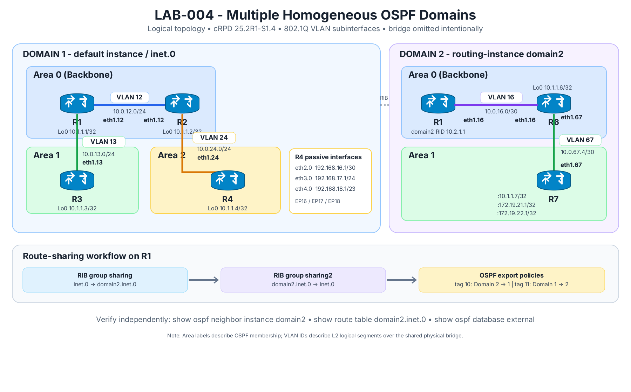
Figure 2 : Multiple OSPF Domain

Load Config
# r1,r2,r3,r4,r6,r7
load override /lab-configs/ospf.multiarea.conf
commit

Task 1
- On R1, create routing-instance domain2 with instance-type virtual-router.
- Assign R1's eth1.16 to domain2. Configure the instance router ID 10.2.1.1.
- Configure OSPF Area 0 on domain2 interface eth1.16.
- On R6, set router ID 10.1.1.6. Configure Area 0 on eth1.16 and advertise lo0.0 passively in Area 0.
- On R6 and R7, configure Area 1 on eth1.67. Set R7 router ID 10.1.1.7 and advertise R7's lo0.0 passively in Area 1. The three /32 addresses (10.1.1.7, 172.19.21.1, and 172.19.22.1) all reside on this single unit.
- Keep the default broadcast network type on VLAN 16 and VLAN 67 for this chapter exercise. Verify adjacency in both domains.
Acceptance criteria:
- At R1, show ospf neighbor instance domain2 shows R6 Full.
- At R6, show ospf neighbor shows R1 and R7 Full (under the relevant areas).
- At R7, R6 is Full.
- R1 shows distinct route tables inet.0 and domain2.inet.0.
# r1 shell
ip route show table all
ip rule show
ip -d link show type vrf
ip vrf show

ping -I __crpd-vrf1 -c 3 10.0.16.2

TASK 2
- On R1, Create RIB group sharing with import-rib [ inet.0 domain2.inet.0 ].
- Create RIB group sharing2 with import-rib [ domain2.inet.0 inet.0 ].
- Apply sharing under the main protocols ospf hierarchy.
- Apply sharing2 under routing-instances domain2 protocols ospf.
- Commit and inspect both RIBs again. Check which OSPF routes are now copied into the other table before enabling cross-domain external LSA export.

TASK 3
On R1 create the two policies :
- from_domain1 matches protocol ospf, sets external tag 11, then accepts.
- from_domain2 matches instance domain2, sets external tag 10, then accepts.
- Apply from_domain2 under the default protocols ospf export statement.
- Apply from_domain1 under routing-instances domain2 protocols ospf export.
- Commit. Verify OSPF route tables and external LSAs on R1, R2, R6 and R7.

Lab 005 Multi AS

Load Config
# r1,r2,r3,r4,r6,r7
conf

load replace /lab-configs/ospf.multidomain.conf

TASK 1
- Configure router IDs and autonomous system 65002 on R8/R9.
- On R8, make lo0.0 passive in OSPF Area 0. Configure eth1.89 in Area 1 with OSPF point-to-point network type.
- On R9, configure eth1.89 in Area 1 point-to-point; make lo0.0, eth2.0 and eth3.0 passive in Area 1.
- Verify R8-R9 Full adjacency and R8's OSPF routes to 192.168.91.0/24 and 192.168.92.0/24. At this stage these routes must not be in AS 65001.

TASK 2
- Configure routing-options autonomous-system 65001 on R2 and a BGP external group to peer with 10.0.28.2, peer-as 65002.
- Configure routing-options autonomous-system 65002 on R8 and a BGP external group to peer with 10.0.28.1, peer-as 65001.
- Commit and verify show bgp summary on both devices. Before export policies are attached, the eBGP session should be Established with no OSPF routes exchanged.

TASK 3
- On R2, create policy ospf-to-bgp matching protocol ospf and accepting it.
- Apply the policy to the eBGP group export on R2.
- Verify R8 receives routes from AS 65001 as BGP routes, using `show route protocol bgp` and `show route <prefix> detail`.
- Confirm that these prefixes do not yet appear as Type-5 LSAs in R8's OSPF database merely because BGP received them. This demonstrates that route propagation between protocols requires an explicit redistribution policy.

TASK 4
- On R8, create an OSPF-to-BGP export policy matching protocol ospf and r8's loopback. apply it to the eBGP group toward R2.
- Verify R2 receives the AS 65002 routes as BGP routes, including 10.1.1.8/32, 10.1.1.9/32, 192.168.91.0/24 and 192.168.92.0/24.

TASK 5
- On R8, create a policy matching protocol bgp and accepting it; apply it as ‘protocols ospf export’. This injects AS 65001 BGP routes into AS 65002 OSPF.
- On R2, create the equivalent BGP-to-OSPF policy and apply it under the default protocols ospf export. This injects AS 65002 BGP routes into AS 65001.
- Verify Type-5 external LSAs, OSPF path types, and end-to-end reachability:
  - From an EP16/EP17/EP18 host, ping EP91 and EP92.
  - From EP91/EP92, ping an EP16/EP17/EP18 host.
  - Use shell ping with the host's normal default gateway. cRPD does not provide a Junos operational `ping` command in this image; use its Linux shell when testing router-sourced packets.
- Identify the ASBRs and explain why BGP-learned routes do not automatically appear in the remote OSPF LSDB until the export policy is applied.

Lab 006 Virtual Link

Load Config
# r1,r2,r3,r4
conf
load replace /lab-configs/ospf.virtual-link.conf
commit

TASK 1
- Configure router IDs on R4 and R10 using 10.1.1.4 and 10.1.1.10.
- Put R4 eth1.410 and R10 eth1.410 in Area 2, both point-to-point. Area 2 must be a normal transit area, not a stub area.
- Put R10 lo0.0, eth2.0, and eth3.0 passively in Area 3. The latter two interfaces advertise 192.168.76.0/24 and 192.168.77.0/24.
- Verify all physical OSPF adjacencies and inspect OSPF databases on R2 and R10.
ACCEPTANCE CRITERIA
- R2-R4 and R4-R10 reach Full on Area 2.
- R10 advertises 192.168.76.0/24 and 192.168.77.0/24 in Area 3.
- R4 is the transit router between R2 and R10 inside Area 2.
- No virtual-link interface is present yet; all configured adjacencies are physical.
- On R1 and R2, verify that the Area 3 prefixes are not installed as OSPF routes.

TASK 2
- On R2, configure a virtual link under Area 0 with neighbor ID 10.1.1.10 and transit area 0.0.0.2.
- On R10, configure the reciprocal virtual link under Area 0 with neighbor ID 10.1.1.2 and transit area 0.0.0.2.
- Run `commit check`, then `commit`, on both routers.
- Verify the virtual-link neighbor reaches Full. Inspect the virtual interface detail to confirm the transit area.
ACCEPTANCE CRITERIA
- Both virtual-link endpoint configurations use Area 2 (0.0.0.2) as transit area.
- R2 identifies R10 by router ID 10.1.1.10; R10 identifies R2 by 10.1.1.2.
- A virtual OSPF interface is shown on both routers and its neighbor state is Full.
- The physical Area 0, Area 1, and Area 2 adjacencies remain Full.

TASK 3
- On R2, inspect show route 192.168.76.0/24 exact and show route 192.168.77.0/24 exact.
- Repeat the route checks on R1 and R3. Identify the route path type using `show ospf route` or `show ospf route inter` where supported.
- Inspect the Area 0 LSDB and the R10 Router LSA detail from R2. Identify the virtual link entry and verify that Area 3 prefixes are now visible in OSPF.
- Compare the results with TASK 3 and explain what changed after virtual-link establishment.
ACCEPTANCE CRITERIA
- R2 and R1 learn 192.168.76.0/24 and 192.168.77.0/24 through OSPF after the virtual link is Full; R3 also learns the prefixes through the multi-area domain.
- The routes are not external Type-5 LSAs; they are internal/inter-area routes.
- OSPF interface detail identifies a virtual interface with transit Area 2.
- The R10 Router LSA / Area 0 database shows the virtual-link relationship.

Lab 007 OSPF Interface Type
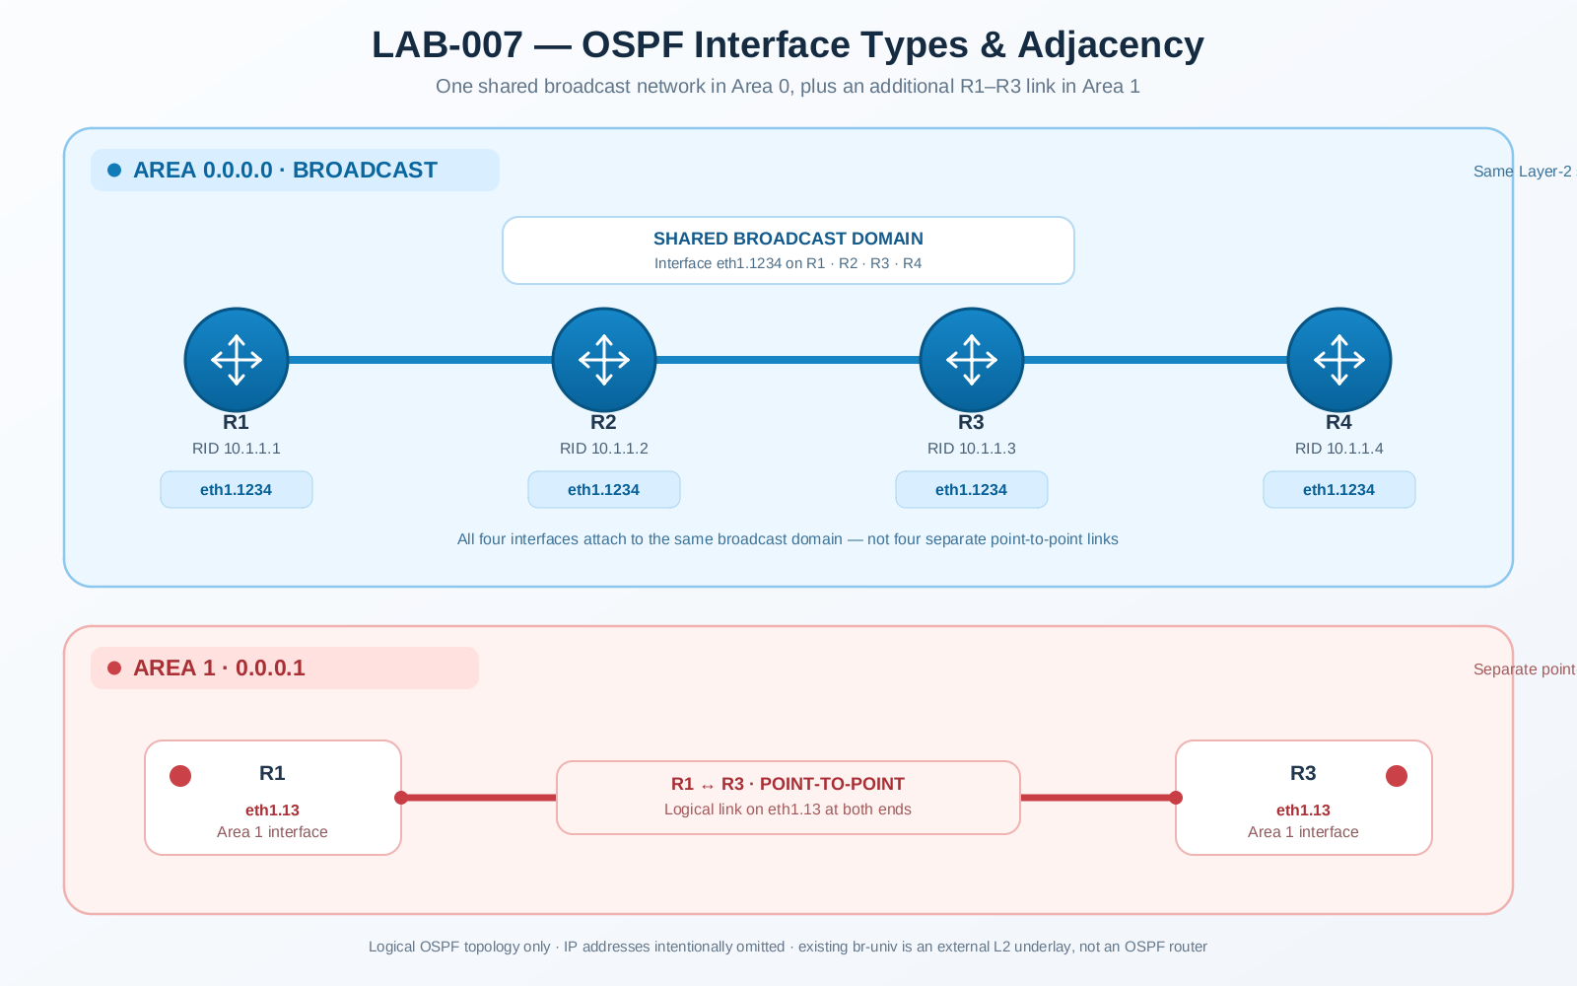
Figure 0-3 OSPF Interface Type

Load Config
# r1,r2,r3,r4
conf
load override /lab-configs/ospf.lab007.conf
commit

TASK 1
- Inspect show ospf interface eth1.1234 detail and show ospf neighbor detail on all routers.
- Identify the elected DR and BDR and the DROther router(s).
- Explain why two DROther routers can remain 2-Way with each other while forming Full adjacencies with DR/BDR.
- Inspect show ospf database network detail and correlate the Network LSA with the shared segment.

TASK 2
- Set VLAN 1234 priorities: R1 = 200, R2 = 100, R3 = 0, R4 = 0.
- Commit and observe whether the existing DR/BDR changes immediately.
- Explain OSPF's non-preemptive DR election behavior.
- Cause a controlled fresh election using a maintenance-safe method in the lab. Do not reset or recreate br-univ. (clear ospf neighbor interface eth1.1234)
- Verify DR/BDR and the effect of priority 0.
ACCEPTANCE CRITERIA
- R3 and R4 is ineligible for DR/BDR while its priority is 0.
- After a fresh election, R1 should be DR and R2 eligible for BDR if both are operational.
- The learner explains why changing priority alone may not replace the current DR/BDR.

TASK 3
- Verify VLAN 13 is point-to-point on both R1 and R3.
- Record interface and neighbor state.
- Change both ends of VLAN 13 to broadcast and commit.
- Observe adjacency and DR/BDR behavior on the two-router segment.
- Restore point-to-point on both ends and verify Full.
ACCEPTANCE CRITERIA
- Both ends use matching interface types during each test.
- Point-to-point mode does not use DR/BDR election.
- Broadcast mode exhibits broadcast-network behavior and election where applicable.
- VLAN 13 is restored to point-to-point and adjacency returns to Full.

Lab 008 OSPF Multi Area Adj
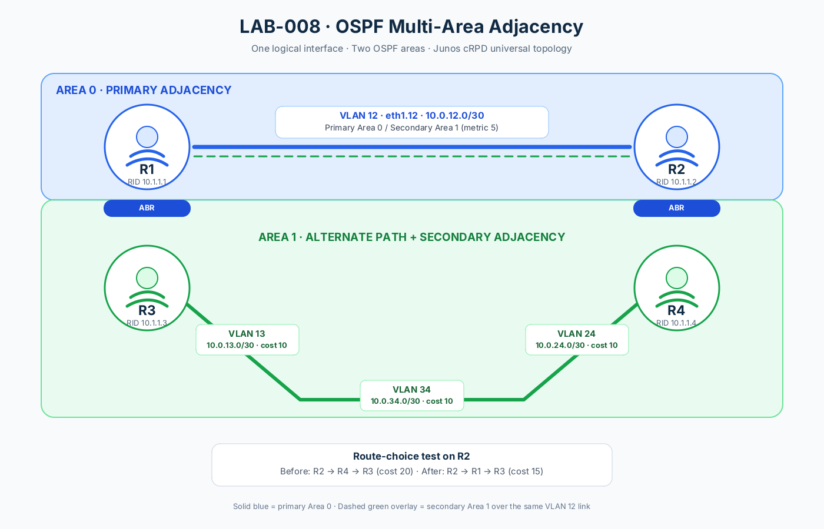
Figure 0-4 OSPF Multi Area Adj

Load Config
# r1,r2,r3,r4
conf
load override /lab-configs/ospf.multiarea-adj.conf
commit

TASK 1
- On R2, inspect the route to R3's loopback 10.1.1.3/32. Record the next hop and metric before enabling the multi-area adjacency.
- On R1 and R2, configure eth1.12 as a secondary interface in Area 1 and set its Area 1 metric to 5.
- Run commit check on both routers before committing.
- Do not add a second IP address to VLAN 12. The secondary adjacency reuses the same logical interface and is an unnumbered point-to-point link in the secondary area.
ACCEPTANCE CRITERIA
- Both routers accept the secondary-interface configuration.
- show ospf interface detail shows eth1.12 in Area 0 as the primary interface and in Area 1 as secondary.
- The secondary adjacency between R1 and R2 is Full in Area 1 as well as the existing Full adjacency in Area 0.
- The other Area 1 adjacencies remain Full.
root@r2# run show route 10.1.1.3/32 detail

inet.0: 13 destinations, 13 routes (13 active, 0 holddown, 0 hidden)
10.1.1.3/32 (1 entry, 1 announced)
*OSPF Preference: 10
Next hop type: Router, Next hop index: 0
Address: 0x55f9e98e20fc
Next-hop reference count: 8, Next-hop session id: 0
Kernel Table Id: 0
Next hop: 10.0.24.2 via eth1.24, selected
Session Id: 0
State: <Active Int>
Age: 9:28 Metric: 20
Validation State: unverified
Area: 0.0.0.1
Task: OSPF
Announcement bits (2): 1-KRT MFS 2-KRT
AS path: I
Thread: junos-main

root@r2# set protocols ospf area 1 interface eth1.12 secondary metric 5

[edit]
root@r2# commit

TASK 2
- On R2, inspect show route 10.1.1.3/32 exact and `show ospf route` again.
- Compare the selected Area 1 path and metric with the baseline recorded in Task 0.
- Verify the Area 1 link-state database and confirm that the R1-R2 secondary link is represented as a point-to-point unnumbered adjacency.
- Explain why the route preference can change even though no new physical/parent interface or IP subnet was added.
ACCEPTANCE CRITERIA
- R2's preferred intra-area path to R3's loopback moves from the R2-R4-R3 route to the lower-cost path through R1 using eth1.12 .
- The new Area 1 path is preferred because its cost is lower than the alternate route;
- The primary Area 0 adjacency remains Full and keeps the same IP subnet.
- No static route is added to force the preferred path.
root@r2# run show route 10.1.1.3/32 detail

inet.0: 13 destinations, 13 routes (13 active, 0 holddown, 0 hidden)
10.1.1.3/32 (1 entry, 1 announced)
*OSPF Preference: 10
Next hop type: Router, Next hop index: 0
Address: 0x55f9e98e319c
Next-hop reference count: 6, Next-hop session id: 0
Kernel Table Id: 0
Next hop: 10.0.12.1 via eth1.12, selected
Session Id: 0
State: <Active Int>
Age: 1:06 Metric: 15
Validation State: unverified
Area: 0.0.0.1
Task: OSPF
Announcement bits (2): 1-KRT MFS 2-KRT
AS path: I
Thread: junos-main

Lab 009 OSPFv3
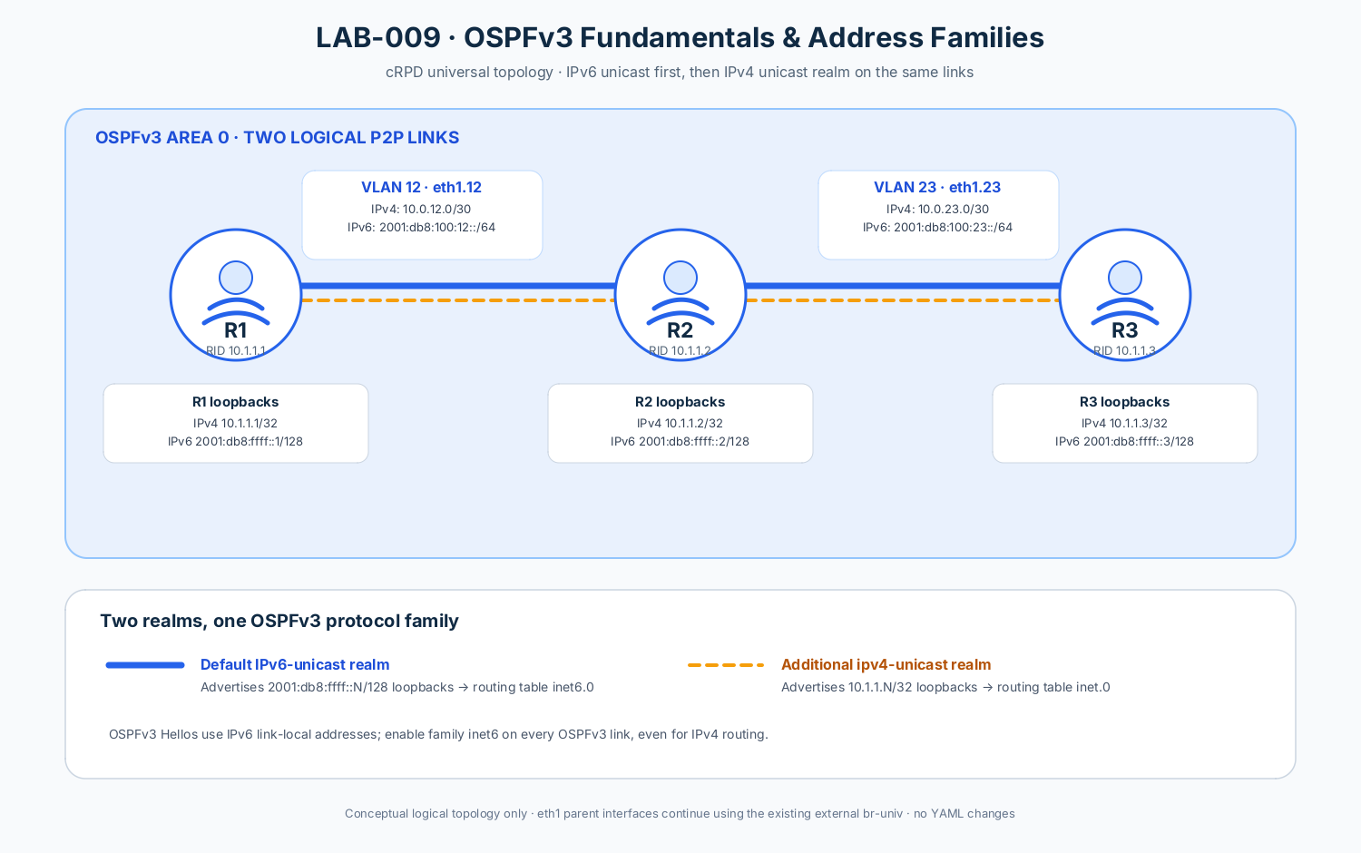
Figure 0-5 OSPFv3 Basics

Load Config
# r1,r2,r3
conf
load override /lab-configs/ospfv3.basic.conf
commit

TASK 1
- Configure Area 0 OSPFv3 on R1's eth1.12 and passive lo0.0.
- Configure Area 0 OSPFv3 on R2's eth1.12, eth1.23, and passive lo0.0.
- Configure Area 0 OSPFv3 on R3's eth1.23 and passive lo0.0.
- Run `commit check` and `commit` on each router.
- Verify the R1-R2 and R2-R3 neighbor relationships and IPv6 loopback routes.
ACCEPTANCE CRITERIA
- OSPFv3 neighbors form on R1-R2 and R2-R3 in Area 0.
- R1 learns 2001:db8:ffff::3/128 in inet6.0 through R2; R3 learns 2001:db8:ffff::1/128 through R2.
- The route is learned through OSPFv3, not a static route.
- `show ospf3 interface` shows the expected OSPFv3 interfaces.

TASK 2
- On R1, add realm ipv4-unicast Area 0 interfaces for eth1.12 and passive lo0.0.
- On R2, add realm ipv4-unicast Area 0 interfaces for eth1.12, eth1.23, and passive lo0.0.
- On R3, add realm ipv4-unicast Area 0 interfaces for eth1.23 and passive lo0.0.
- Run `commit check` before committing each router.
- Verify IPv4-realm interface/LSDB state and routes in inet.0. Compare with the IPv6-unicast realm and inet6.0.
ACCEPTANCE CRITERIA
- The IPv4-unicast realm is present on both links and each router's passive loopback.
- R1 learns 10.1.1.3/32 in inet.0 through R2; R3 learns 10.1.1.1/32 through R2.
- The IPv4 routes are learned using OSPFv3's IPv4-unicast realm; they are not static and are not dependent on OSPFv2.
- `show ospf3 database realm ipv4-unicast` displays the IPv4-unicast link-state database.
- IPv6-unicast reachability remains operational after enabling the IPv4 realm.
root@r2# show protocols | display set
set protocols ospf3 realm ipv4-unicast area 0.0.0.0 interface lo0.0 passive
set protocols ospf3 realm ipv4-unicast area 0.0.0.0 interface eth1.12
set protocols ospf3 realm ipv4-unicast area 0.0.0.0 interface eth1.23

root@r2# run show ospf3 neighbor detail
ID Interface State Pri Dead
10.1.1.1 eth1.12 Full 128 33
Neighbor-address fe80::a8c1:abff:fe27:ce77
Area 0.0.0.0, opt 0x13, OSPF3-Intf-Index 2
DR-ID 10.1.1.2, BDR-ID 10.1.1.1
Up 00:07:15, adjacent 00:06:35
10.1.1.3 eth1.23 Full 128 32
Neighbor-address fe80::a8c1:abff:fed4:6649
Area 0.0.0.0, opt 0x13, OSPF3-Intf-Index 2
DR-ID 10.1.1.3, BDR-ID 10.1.1.2
Up 00:05:30, adjacent 00:05:30

[edit]
root@r2# run show ospf3 neighbor realm ipv4-unicast detail
ID Interface State Pri Dead
10.1.1.1 eth1.12 Full 128 37
Neighbor-address fe80::a8c1:abff:fe27:ce77
Area 0.0.0.0, opt 0x112, OSPF3-Intf-Index 2
DR-ID 10.1.1.2, BDR-ID 10.1.1.1
Up 00:02:02, adjacent 00:01:13
10.1.1.3 eth1.23 Full 128 39
Neighbor-address fe80::a8c1:abff:fed4:6649
Area 0.0.0.0, opt 0x112, OSPF3-Intf-Index 2
DR-ID 10.1.1.3, BDR-ID 10.1.1.2
Up 00:02:02, adjacent 00:01:22

Lab 010 OSPFv3 Virtual Link
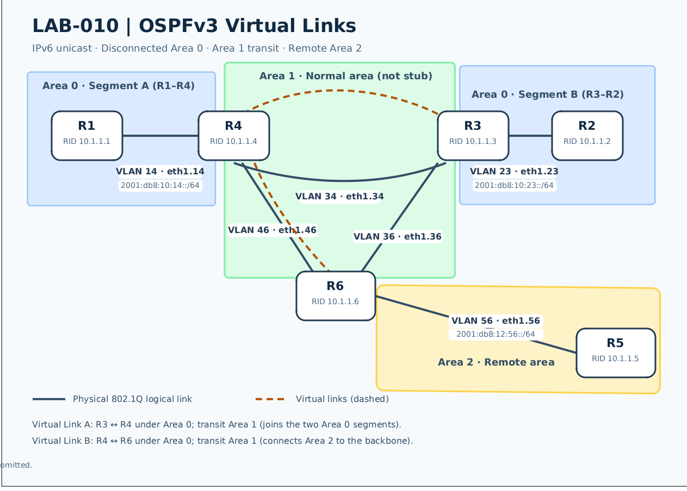
Figure 0-6 OSPFv3 Virtual Link

Load Config
# r1,r2,r3,r4,r5,r6
conf
load override /lab-configs/ospfv3.virtual-link.conf
commit

TASK 1
Verify protocols ospf3 configuration for IPv6 unicast only:
- R1: Area 0 on eth1.14; lo0.0 passive in Area 0.
- R2: Area 0 on eth1.23; lo0.0 passive in Area 0.
- R3: Area 0 on eth1.23; Area 1 on eth1.34 and eth1.36; lo0.0 passive in Area 1.
- R4: Area 0 on eth1.14; Area 1 on eth1.34 and eth1.46; lo0.0 passive in Area 1.
- R6: Area 1 on eth1.36 and eth1.46; Area 2 on eth1.56; lo0.0 passive in Area 1.
- R5: Area 2 on eth1.56; lo0.0 passive in Area 2.
- Record which remote loopback routes are present and missing on R1 , R2, and R5.

TASK 2
Configure virtual links under Area 0 on both endpoints of each link.
- Virtual link A connects R3 (Router ID 10.1.1.3) and R4 (Router ID 10.1.1.4), using Area 1 as transit area.
- Virtual link B connects R4 (Router ID 10.1.1.4) and R6 (Router ID 10.1.1.6), using Area 1 as transit area.

TASK 3
On R1, R3, R4, R6 and R10, collect:
- run show ospf3 interface
- run show ospf3 neighbor detail
- run show ospf3 database extensive
- run show ospf3 route
- run show route protocol ospf3

Lab 011 Area-Range Summarization
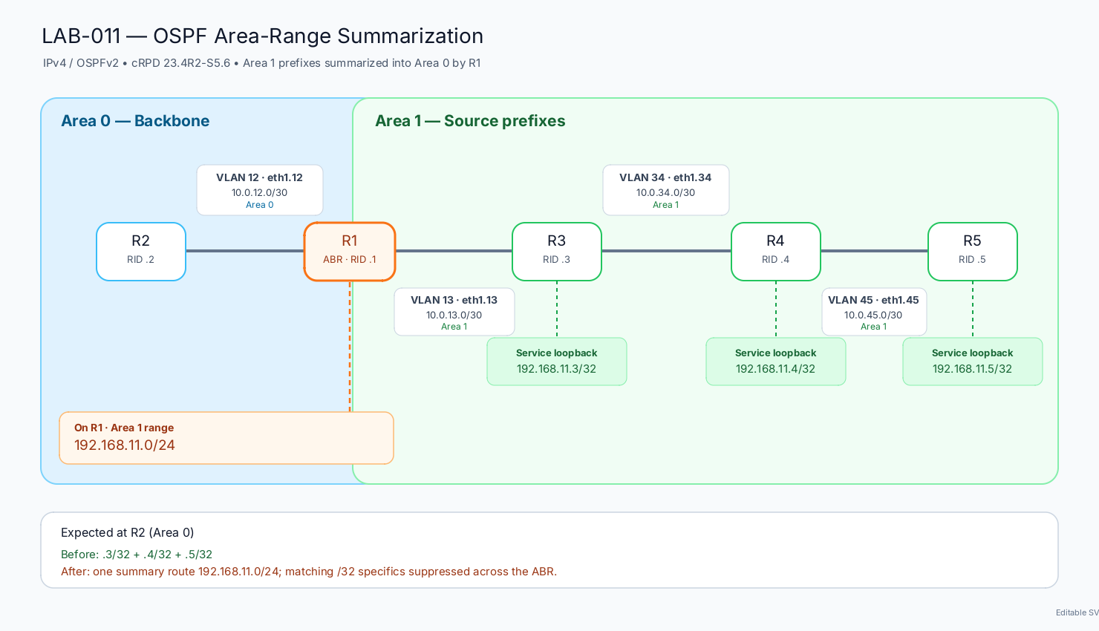
Figure 0-7 OSPF Area-Range

Load Config
# r1,r2,r3,r4,r5
conf
load override /lab-configs/ospf.area-range.conf
commit

TASK 1
- Verify all four logical links are up/up.
- Verify OSPFv2 adjacencies are Full on R1–R2, R1–R3, R3–R4, and R4–R5.
- On R2, inspect the OSPF routes for 192.168.11.3/32, 192.168.11.4/32, and 192.168.11.5/32.
- Confirm the individual /32 prefixes are learned before summarization and that 192.168.11.0/24 is not yet advertised as the summary.

TASK 2
On R1, configure the Area 1 area range so the three service loopbacks are summarized into 192.168.11.0/24 when routes cross into Area 0.
- Apply the range under the source area (Area 1) on R1.
- Run commit check before commit.

TASK 3
- On R1, modify the range to add the restrict option.
- Commit and verify on R2 that neither the individual /32 routes nor the 192.168.11.0/24 summary are advertised. This is filter-only behavior.
- Restore summarization mode by deleting the restrict form.

Lab 012 Metric Preference
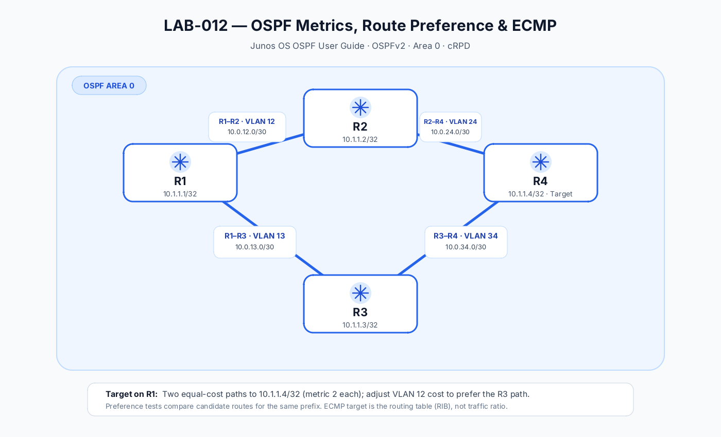
Figure 0-8 OSPF Metric Preference

Load Config
# r1,r2,r3,r4
conf
load override /lab-configs/ospf.metric.conf
commit

TASK 1
- On R1 only, set the OSPF metric on eth1.12 to 20.
- Run ‘commit check’ and commit.
Verify on R1:
- The cost of eth1.12 is now 20.
- Route 10.1.1.4/32 uses the path through R3 (next-hop 10.0.13.2 via eth1.13), because the cost via R2 is now higher.
- The route is no longer ECMP; the alternate path through R2 should not be an equal-cost active next-hop.

Lab 013 Overload, SPF & LSA Flooding
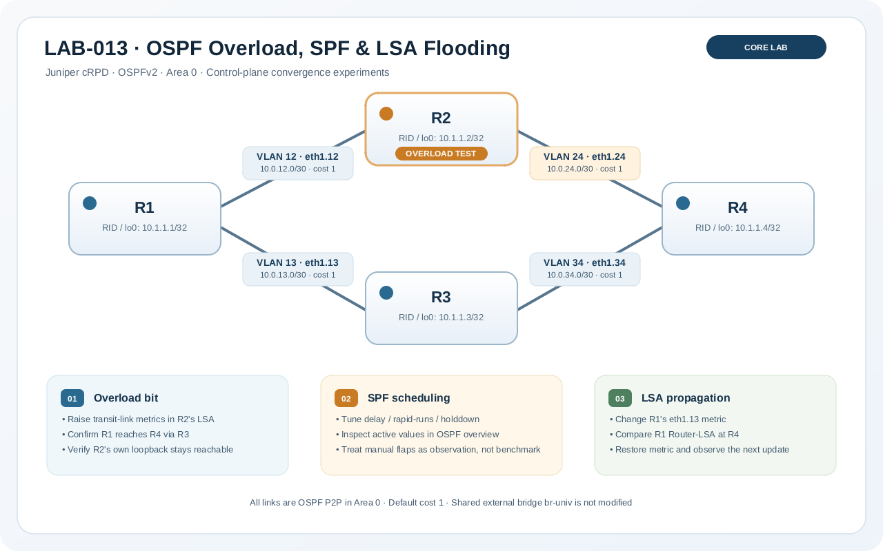
Figure 0-9 Overload SPF LSA Flooding

Load Config
# r1,r2,r3,r4
conf
load override /lab-configs/ospf.overload.conf
commit

TASK 1
Configure R2 so that OSPF considers it unsuitable for transit traffic while keeping the router and its adjacencies participating in OSPF.
Prove all of the following from operational state:
- R2's Router-LSA advertises its transit links with the maximum OSPF metric while the drain is active.
- R1 selects the path via R3 to reach R4's loopback rather than transiting R2.
- R2's own loopback remains reachable from R1.
Capture the relevant evidence before removing the drain setting.
# r2
set protocol ospf overload
# r1
root@r1# run show ospf database router advertising-router 10.1.1.2 detail

OSPF database, Area 0.0.0.0
Type ID Adv Rtr Seq Age Opt Cksum Len
Router 10.1.1.2 10.1.1.2 0x80000007 26 0x22 0x93a6 84
bits 0x0, link count 5
id 10.1.1.1, data 10.0.12.2, Type PointToPoint (1)
Topology count: 0, Default metric: 65535
id 10.0.12.0, data 255.255.255.252, Type Stub (3)
Topology count: 0, Default metric: 1
id 10.1.1.4, data 10.0.24.1, Type PointToPoint (1)
Topology count: 0, Default metric: 65535
id 10.0.24.0, data 255.255.255.252, Type Stub (3)
Topology count: 0, Default metric: 1
id 10.1.1.2, data 255.255.255.255, Type Stub (3)
Topology count: 0, Default metric: 0
Topology default (ID 0)
Type: PointToPoint, Node ID: 10.1.1.4
Metric: 65535, Bidirectional
Type: PointToPoint, Node ID: 10.1.1.1
Metric: 65535, Bidirectional

root@r1# run show route 10.1.1.4 detail

inet.0: 13 destinations, 13 routes (13 active, 0 holddown, 0 hidden)
10.1.1.4/32 (1 entry, 1 announced)
*OSPF Preference: 10
Next hop type: Router, Next hop index: 0
Address: 0x5609420e20fc
Next-hop reference count: 6, Next-hop session id: 0
Kernel Table Id: 0
Next hop: 10.0.13.2 via eth1.13, selected
Session Id: 0
State: <Active Int>
Age: 42 Metric: 2
Validation State: unverified
Area: 0.0.0.0
Task: OSPF
Announcement bits (2): 1-KRT MFS 2-KRT
AS path: I
Thread: junos-main

root@r1# run show route 10.1.1.2

inet.0: 13 destinations, 13 routes (13 active, 0 holddown, 0 hidden)
+ = Active Route, - = Last Active, * = Both

10.1.1.2/32 *[OSPF/10] 00:08:42, metric 1
> to 10.0.12.2 via eth1.12

# r2
rollback 1
commit

TASK 2
On R1, configure non-default SPF scheduling values so that the active values are easy to distinguish from defaults:
- delay: 600 ms
- rapid-runs: 2
- holddown: 8000 ms
# r1
root@r1# run show ospf overview
Instance: master
Router ID: 10.1.1.1
Route table index: 0
LSA refresh time: 50 minutes
Post Convergence Backup: Disabled
Area: 0.0.0.0
Stub type: Not Stub
Authentication Type: None
Area border routers: 0, AS boundary routers: 0
Neighbors
Up (in full state): 2
Topology: default (ID 0)
Prefix export count: 0
Full SPF runs: 14
SPF delay: 0.200000 sec, SPF holddown: 5 sec, SPF rapid runs: 3
Backup SPF: Not Needed

set protocols ospf spf-options delay 600
set protocols ospf spf-options holddown 8000
set protocols ospf spf-options rapid-runs 2

root@r1# run show ospf overview
Instance: master
Router ID: 10.1.1.1
Route table index: 0
LSA refresh time: 50 minutes
Post Convergence Backup: Disabled
Area: 0.0.0.0
Stub type: Not Stub
Authentication Type: None
Area border routers: 0, AS boundary routers: 0
Neighbors
Up (in full state): 2
Topology: default (ID 0)
Prefix export count: 0
Full SPF runs: 15
SPF delay: 0.600000 sec, SPF holddown: 8 sec, SPF rapid runs: 2
Backup SPF: Not Needed

TASK 3
Use a local link-cost change to make the effect of LSA origination and flooding observable.
- Capture R4's current copy of R1's Router-LSA and R4's route to R1's loopback. Record sequence/checksum and path/cost details if available.
- Change the OSPF cost on R1's eth1.13 link to 7. Do not change the cost on R3's end of the link.
- Prove that:
  - R1 originates an updated Router-LSA.
  - R4 receives the updated LSA;
  - Compare the advertised link metric and sequence/checksum with the baseline rather than expecting a fixed sequence number.
- Restore R1's `eth1.13` cost to the original default.
root@r4# run show ospf database advertising-router 10.1.1.1 detail

OSPF database, Area 0.0.0.0
Type ID Adv Rtr Seq Age Opt Cksum Len
Router 10.1.1.1 10.1.1.1 0x80000008 2099 0x22 0xf35d 84
bits 0x0, link count 5
id 10.1.1.2, data 10.0.12.1, Type PointToPoint (1)
Topology count: 0, Default metric: 1
id 10.0.12.0, data 255.255.255.252, Type Stub (3)
Topology count: 0, Default metric: 1
id 10.1.1.3, data 10.0.13.1, Type PointToPoint (1)
Topology count: 0, Default metric: 1
id 10.0.13.0, data 255.255.255.252, Type Stub (3)
Topology count: 0, Default metric: 1
id 10.1.1.1, data 255.255.255.255, Type Stub (3)
Topology count: 0, Default metric: 0
Topology default (ID 0)
Type: PointToPoint, Node ID: 10.1.1.3
Metric: 1, Bidirectional
Type: PointToPoint, Node ID: 10.1.1.2
Metric: 1, Bidirectional

root@r1# set protocols ospf area 0 interface eth1.13 metric 7

[edit]
root@r1# commit
commit complete

root@r4# run show ospf database advertising-router 10.1.1.1 detail

OSPF database, Area 0.0.0.0
Type ID Adv Rtr Seq Age Opt Cksum Len
Router 10.1.1.1 10.1.1.1 0x80000009 14 0x22 0x3410 84
bits 0x0, link count 5
id 10.1.1.2, data 10.0.12.1, Type PointToPoint (1)
Topology count: 0, Default metric: 1
id 10.0.12.0, data 255.255.255.252, Type Stub (3)
Topology count: 0, Default metric: 1
id 10.1.1.3, data 10.0.13.1, Type PointToPoint (1)
Topology count: 0, Default metric: 7
id 10.0.13.0, data 255.255.255.252, Type Stub (3)
Topology count: 0, Default metric: 7
id 10.1.1.1, data 255.255.255.255, Type Stub (3)
Topology count: 0, Default metric: 0
Topology default (ID 0)
Type: PointToPoint, Node ID: 10.1.1.3
Metric: 7, Bidirectional
Type: PointToPoint, Node ID: 10.1.1.2
Metric: 1, Bidirectional

TASK 4
Investigate whether this cRPD build supports OSPF flood reduction on both ends of the R1–R3 P2P link.
root@r1# set protocols ospf area 0 interface eth1.13 flood-reduction

[edit]
root@r1# commit
commit complete

root@r1# run show ospf interface eth1.13 detail
Interface State Area DR ID BDR ID Nbrs
eth1.13 PtToPt 0.0.0.0 0.0.0.0 0.0.0.0 1
Type: P2P, Address: 10.0.13.1, Mask: 255.255.255.252, MTU: 9500, Cost: 1
Adj count: 1, Flood Reduction
Hello: 10, Dead: 40, ReXmit: 5, Not Stub
Auth type: None
Protection type: None
Topology default (ID 0) -> Cost: 1

root@r3# run show ospf database router detail advertising-router 10.1.1.1

OSPF database, Area 0.0.0.0
Type ID Adv Rtr Seq Age Opt Cksum Len
Router 10.1.1.1 10.1.1.1 0x8000000b 3* 0x22 0xed60 84

————————-cut————————————

Lab 014 Authentication
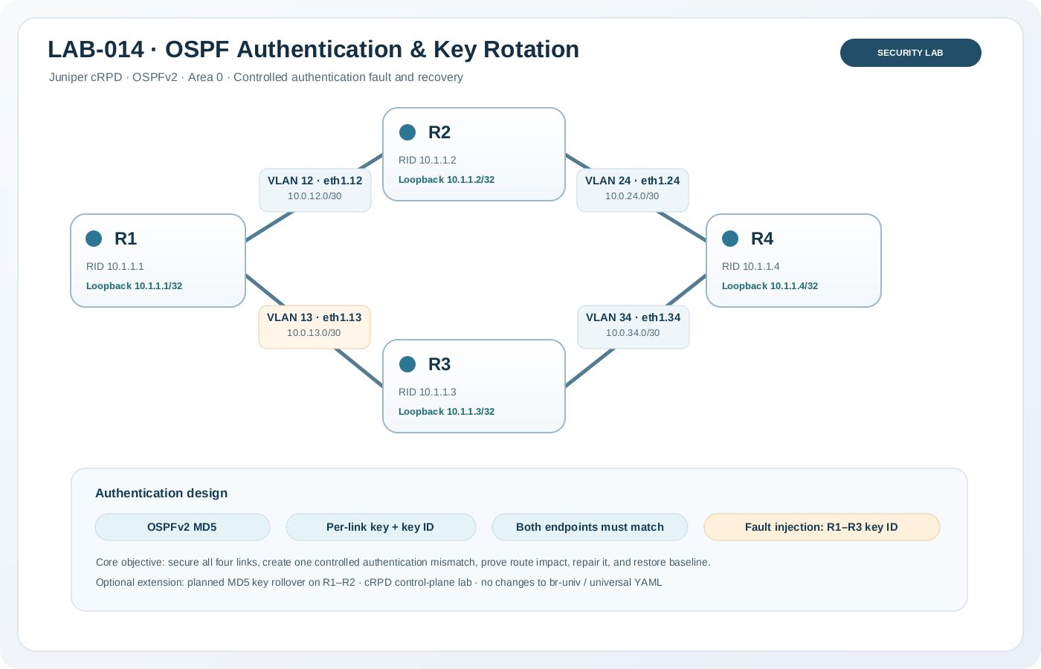
Figure 0-10 OSPF Authentication

Load Config
# r1,r2,r3,r4
conf
load override /lab-configs/ospf.authentication.conf
commit

TASK 2
Apply OSPFv2 MD5 authentication to all four P2P links using the supplied credential matrix.
- The two ends of each link use the same authentication type, key ID, and shared key.
- Each link uses its own key; do not reuse one key across every link.
- Router IDs, IP addressing, OSPF area, interface type, and metrics must remain unchanged.
- All four adjacencies return to Full, and reachability to the loopbacks is preserved.
- Operational interface output shows MD5 and the expected active key ID where this cRPD build exposes those fields.
- Compare configured state with operational state; store evidence from all four routers.
root@r2# run show ospf interface detail
Interface State Area DR ID BDR ID Nbrs
eth1.12 PtToPt 0.0.0.0 0.0.0.0 0.0.0.0 1
Type: P2P, Address: 10.0.12.2, Mask: 255.255.255.252, MTU: 9500, Cost: 1
Adj count: 1
Hello: 10, Dead: 40, ReXmit: 5, Not Stub
Auth type: MD5, Active key ID: 1, Start time: 1970 Jan 1 00:00:00 UTC
Protection type: None
Topology default (ID 0) -> Cost: 1
eth1.24 PtToPt 0.0.0.0 0.0.0.0 0.0.0.0 1
Type: P2P, Address: 10.0.24.1, Mask: 255.255.255.252, MTU: 9500, Cost: 1
Adj count: 1
Hello: 10, Dead: 40, ReXmit: 5, Not Stub
Auth type: MD5, Active key ID: 1, Start time: 1970 Jan 1 00:00:00 UTC
Protection type: None
Topology default (ID 0) -> Cost: 1

TASK 2
- Change only the key ID at one end of R1-R3 to a different ID.
- Keep the shared key text unchanged.
- Capture the resulting neighbor/interface/log state before remediation.
- Restore the matching R1-R3 authentication ID and key at both ends.

TASK 3
On the R1-R2 link only, test an overlap-based key transition:
- Add a second MD5 key with a new key ID and a future start-time while retaining the old key.
- Use exactly the same new key ID, secret, and transition time at both endpoints.
- Ensure router clocks are aligned, and choose a start time far enough in the future to configure both ends.
- Prove that the neighbor remains Full before, during, and after the transition and that the active key ID changes when the feature exposes it.
- Remove the old key only after the new key is confirmed active at both ends.

Lab 015 Timer
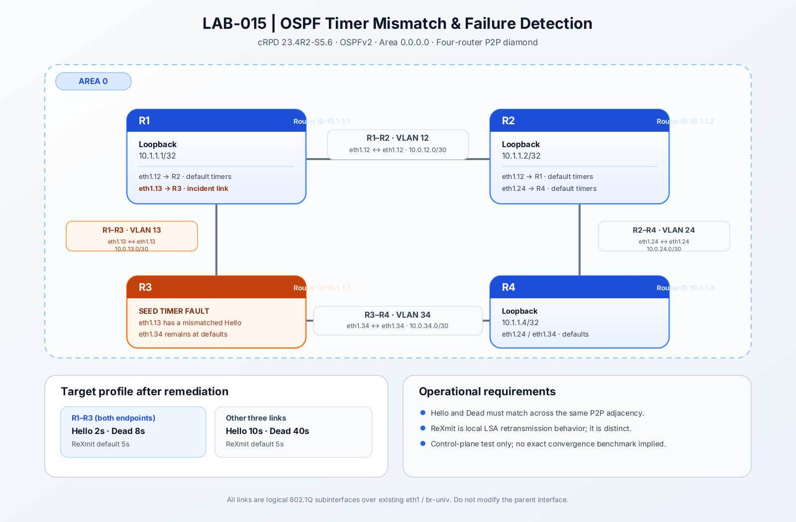

Load Config
# r1,r2,r3,r4
conf
load override /lab-configs/ospf.timer.conf
commit

TASK 1
Determine why the R1-R3 adjacency fails to reach Full, using evidence from both endpoints rather than guessing from the missing neighbor alone.
- Compare operational OSPF interface timer values at both ends of R1-R3.
- Identify the exact incompatible timer value(s), and explain why the resulting mismatch prevents a valid adjacency.

TASK 2
Restore the R1-R3 adjacency using a minimal configuration change. Do not change the IP plan, OSPF area, router IDs, interface type, authentication, metrics, or any other link.
- All four P2P adjacencies return to Full.
- R1's route to 10.1.1.4/32 has next-hops through both R2 and R3 at the baseline total metric 2.

TASK 3
Change only the R1-R3 link to the approved profile: Hello 2 seconds and Dead 8 seconds at both ends. Leave R1-R2, R2-R4, and R3-R4 at the platform defaults. Maintain the original Area 0 P2P diamond and route metrics.
- R1-R3 returns to Full after the coordinated change.
- Both endpoints show matching Hello 2 / Dead 8 timer values.
- Other three links remain at Hello 10 / Dead 40.
- R1 again sees both equal-cost next-hops to `10.1.1.4/32` with total metric 2.

Task 4
Change the LSA retransmission interval on R1's eth1.13 only, while leaving R3's setting at its default. Choose a documented-safe value of at least 3 seconds. Prove from operational output that the retransmit values differ while the R1-R3 adjacency remains Full.
root@r1# run show ospf interface eth1.13 detail
Interface State Area DR ID BDR ID Nbrs
eth1.13 PtToPt 0.0.0.0 0.0.0.0 0.0.0.0 1
Type: P2P, Address: 10.0.13.1, Mask: 255.255.255.252, MTU: 9500, Cost: 1
Adj count: 1
Hello: 2, Dead: 8, ReXmit: 10, Not Stub
Auth type: None
Protection type: None
Topology default (ID 0) -> Cost: 1

root@r3# run show ospf interface eth1.13 detail
Interface State Area DR ID BDR ID Nbrs
eth1.13 PtToPt 0.0.0.0 0.0.0.0 0.0.0.0 1
Type: P2P, Address: 10.0.13.2, Mask: 255.255.255.252, MTU: 9500, Cost: 1
Adj count: 1
Hello: 2, Dead: 8, ReXmit: 5, Not Stub
Auth type: None
Protection type: None
Topology default (ID 0) -> Cost: 1

Lab 016 BFD
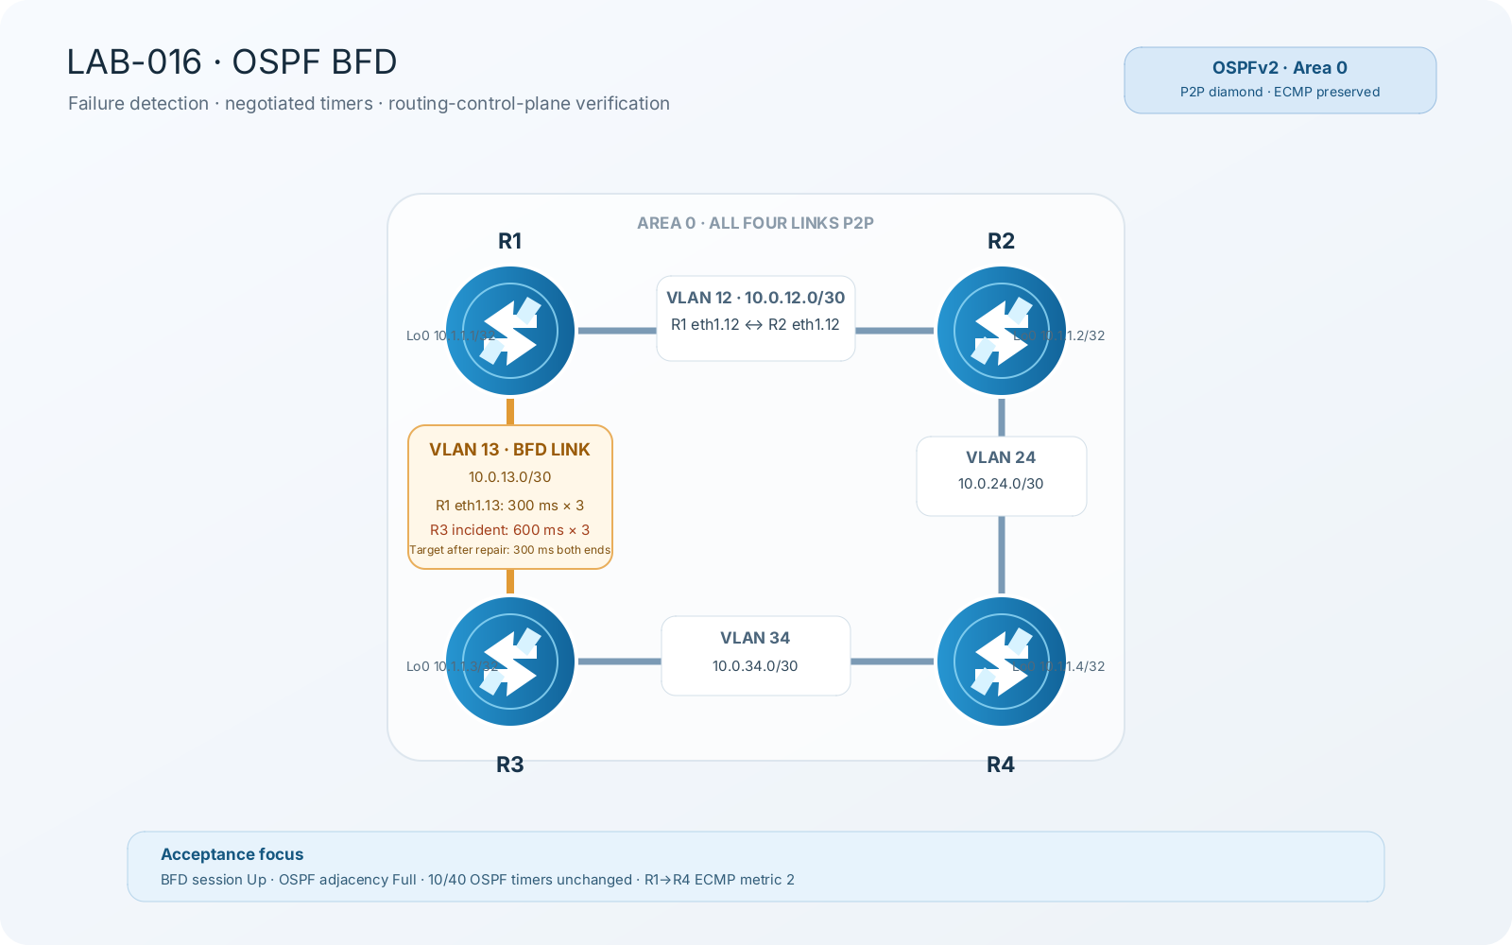

Load Config
# r1,r2,r3,r4
conf
load override /lab-configs/ospf.bfd.conf
commit

Task 1
A change ticket requires a faster fault-detection profile on the R1-R3 OSPF adjacency, without lowering OSPF Hello/Dead timers throughout the area.
- The expected BFD profile is a minimum interval of 300 ms with multiplier 3 at both ends.
- An audit reports that BFD is Up, yet the operational timing shown by the peers is slower than the target.
- Diagnose the difference and correct it with the minimum required change.
root@r1# run show bfd session
Detect Transmit
Address State Interface Time Interval Multiplier
10.0.13.2 Up eth1.13 1.800 0.600 3

1 sessions, 1 clients
Cumulative transmit rate 1.7 pps, cumulative receive rate 1.7 pps

root@r1# run show bfd session extensive
Detect Transmit
Address State Interface Time Interval Multiplier
10.0.13.2 Up eth1.13 1.800 0.600 3
Client OSPF realm ospf-v2 Area 0.0.0.0, TX interval 0.300, RX interval 0.300
Session up time 00:25:29
Local diagnostic None, remote diagnostic None
Remote state Up, version 1
Session type: Single hop BFD
Min async interval 0.300, min slow interval 1.000
Adaptive async TX interval 0.300, RX interval 0.300
Local min TX interval 0.300, minimum RX interval 0.300, multiplier 3
Remote min TX interval 0.600, min RX interval 0.600, multiplier 3
Local discriminator 16, remote discriminator 17
Echo TX interval 0.000, echo detection interval 0.000
Echo mode disabled/inactive
Session ID: 0

1 sessions, 1 clients
Cumulative transmit rate 1.7 pps, cumulative receive rate 1.7 pps

Task 2
- Add the same approved BFD profile to both ends of R2-R4 only.
- Verify an additional BFD session on R2 and R4, all OSPF adjacencies remain Full, and R1's ECMP route to R4 loopback is unchanged.

Lab 017 Graceful Restart
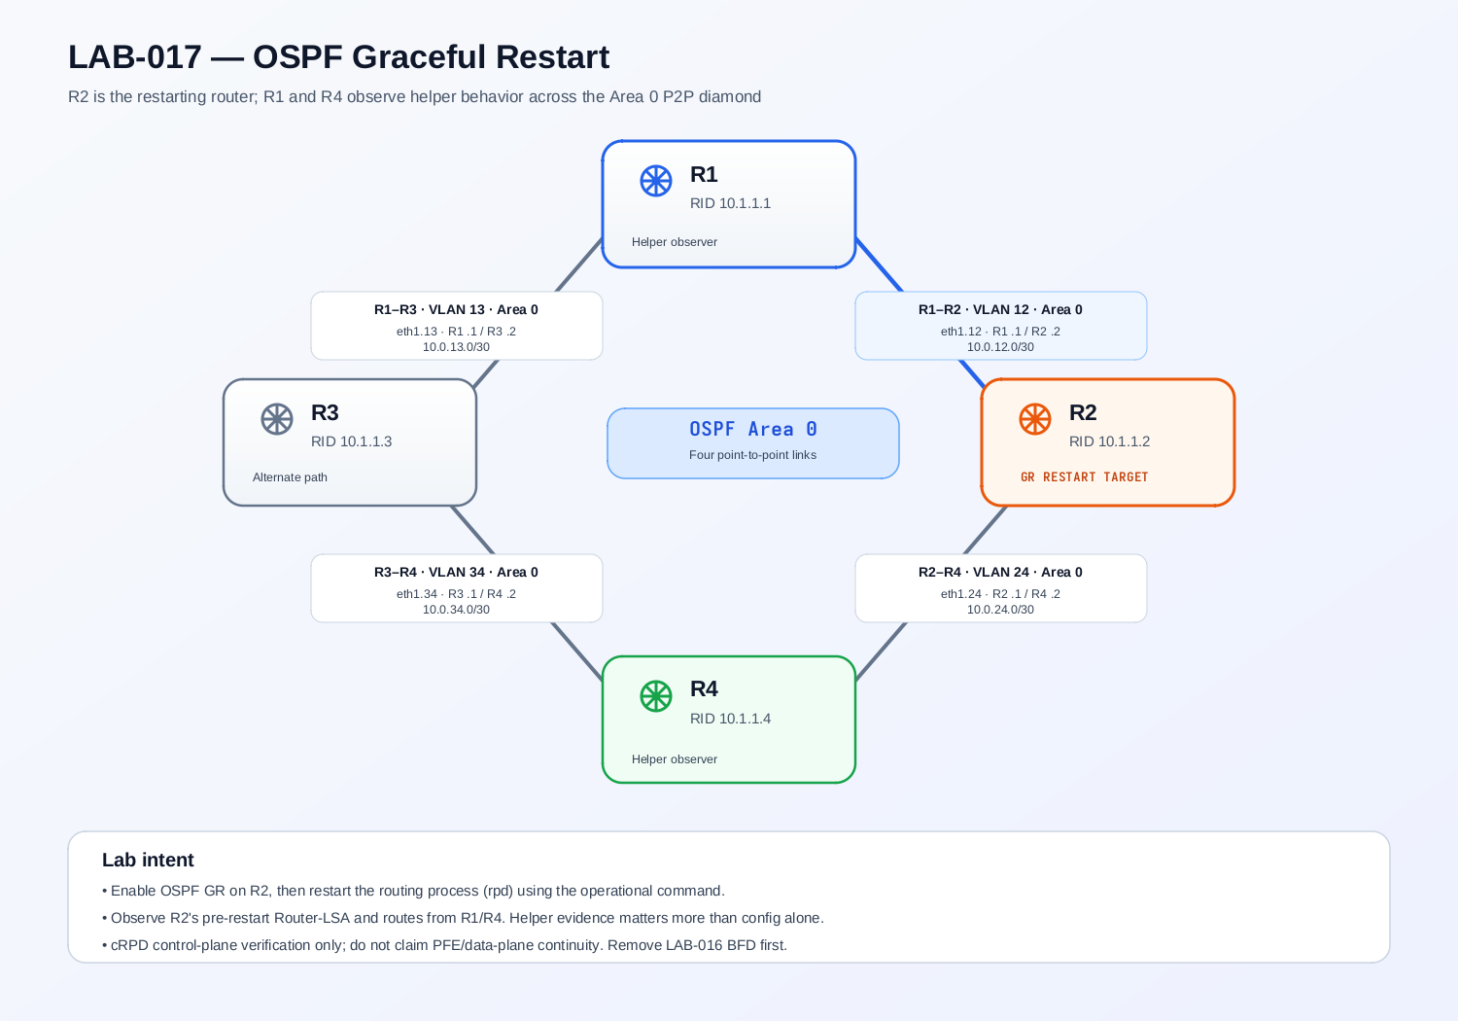

Load Config
# r1,r2,r3,r4 vjunos_router
conf
load override http://10.0.0.2:81/ospf.graceful.cfg routing-instance mgmt_junos
commit

TASK 1
Configure OSPF Graceful Restart for the R2 that will restart. Keep the other routers as helper candidates using their supported/default helper behavior. Do not disable strict LSA checking or disable helper capabilities for the core exercise.
- R2's OSPF overview indicates Graceful Restart is enabled.
- R1 and R4 report the appropriate OSPFv2 helper-mode capabilities enabled, or the exact deviation is documented.
- All four OSPF adjacencies remain Full before the restart.
- R1's ECMP route and LSDB baseline are recorded immediately before the restart.

TASK 2
Restart the routing protocol process on R2 only. Do not restart/stop the whole container, and do not flap links. Observe from R1 and R4 while R2's process is restarting, then inspect R2 after it returns.
Prove or disprove the following expected behavior with operational output/logs:
- R1 and R4 recognize/support R2's graceful restart and preserve their pre-restart view of R2 while the topology remains unchanged.
- R1 continues to show the route to 10.1.1.2/32 during the helper window when the implementation behaves as expected.
- R1's route to 10.1.1.4/32 retains both equal-cost paths via R2 and R3 during the GR window, if helper behavior on this image preserves that RIB state.
- R2's OSPF adjacencies return to Full and its routing/LSDB state resynchronizes after the process restart.
- The GR operation completes rather than remaining indefinitely pending or ending due to a topology/LSA change.

Lab 018 LFA Link Protection
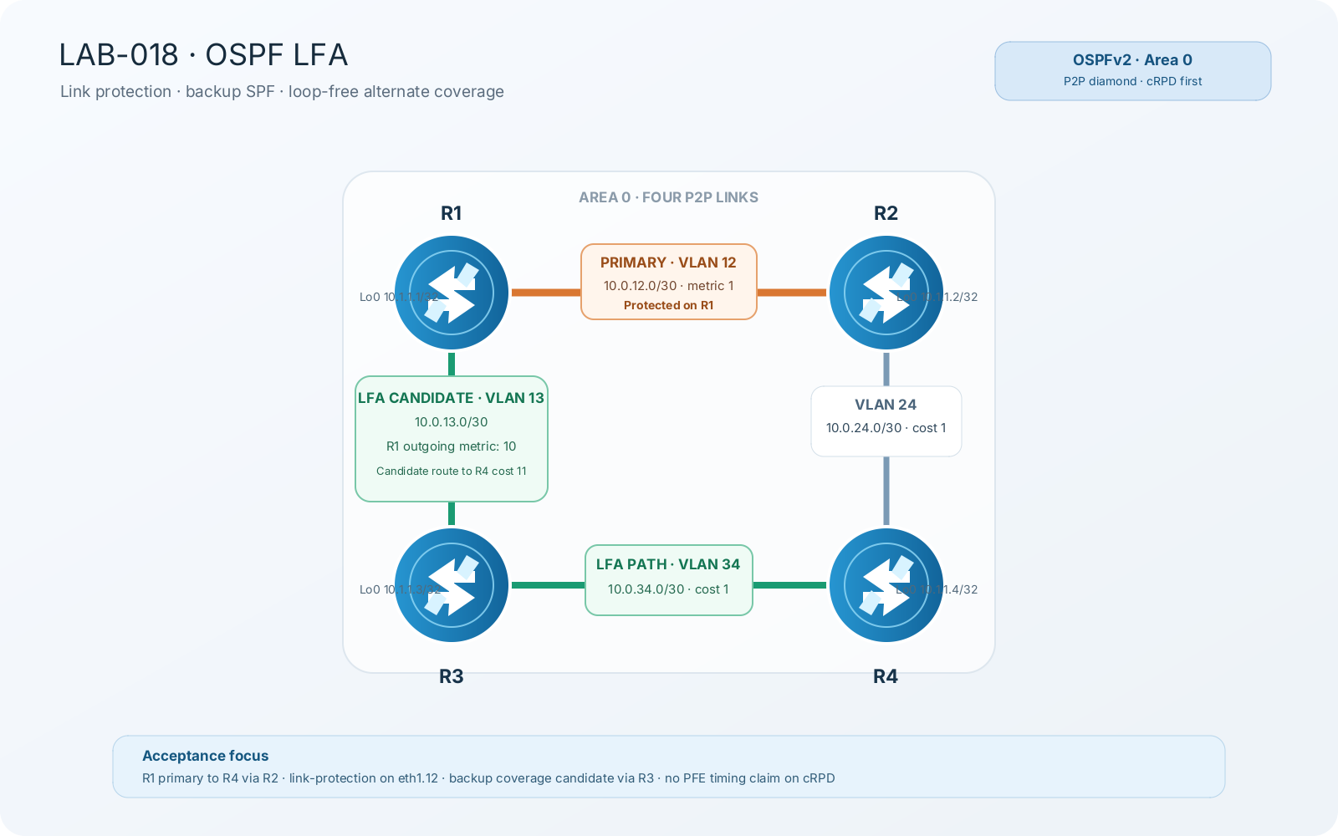

Load Config
# r1,r2,r3,r4 vjunos_router
conf
load override http://10.0.0.2:81/ospf.graceful.cfg routing-instance mgmt_junos
commit

TASK 1
Establish that all four expected P2P adjacencies are Full. Explain why R1's primary route to 10.1.1.4/32 is via R2, and show that the path through R3 is topologically loop-free for this destination.
- OSPF neighbor table for R1-R4.
- R1 route detail for 4.4.4.4/32 showing primary next hop via 10.0.12.2 / ge-0/0/0.12 and metric 2.
- Router-LSA / route evidence sufficient to explain the R1-R3-R4 alternate path.
- Effective metric on R1 eth1.13 and note that the interface cost is directional.
Note : The RFC-style loop-free condition for alternate neighbor N=R3, local repair point S=R1, destination D=R4 is D(N,D) < D(N,S) + D(S,D). Here D(R3,R4)=1, D(R3,R1)=1 (R3's outgoing metric toward R1), and D(R1,R4)=2, so 1 < 1 + 2. Therefore R3 is a valid loop-free alternate candidate for R4.

TASK 2
Provide link protection for the R1-R2 interface that carries the primary route to R4 loopback. Make the minimum change.
- Effective OSPF interface configuration for R1 ge-0/0/0.12.
- show ospf backup coverage.
- show ospf backup neighbor
- show ospf backup spf detail
admin@r1# run show ospf backup coverage
Topology default coverage:

Node Coverage:

Area Covered Total Percent
Nodes Nodes Covered
0.0.0.0 2 3 66.67%

Route Coverage:

Path Type Covered Total Percent
Routes Routes Covered
Intra 4 8 50.00%
Inter 0 0 100.00%
Ext1 0 0 100.00%
Ext2 0 0 100.00%
All 4 8 50.00%

admin@r1# run show ospf backup spf detail
Topology default results:

Area 0.0.0.0 results:

2.2.2.2
Self to Destination Metric: 1
Parent Node: 1.1.1.1
Primary next-hop: ge-0/0/0.12 via 10.0.12.2
Backup Neighbor: 2.2.2.2 via: Direct
Neighbor to Destination Metric: 0, Neighbor to Self Metric: 1
Self to Neighbor Metric: 1, Backup preference: 0x0
Not eligible, Reason: Primary next-hop link fate sharing
Backup Neighbor: 3.3.3.3 via: Direct
Neighbor to Destination Metric: 2, Neighbor to Self Metric: 1
Self to Neighbor Metric: 3, Backup preference: 0x0
Track Item: 1.1.1.1
Track Item: 2.2.2.2
Not eligible, Reason: Path loops

3.3.3.3
Self to Destination Metric: 3
Parent Node: 4.4.4.4
Primary next-hop: ge-0/0/0.12 via 10.0.12.2
Backup next-hop: ge-0/0/0.13 via 10.0.13.3
Backup Neighbor: 3.3.3.3 via: Direct
Neighbor to Destination Metric: 0, Neighbor to Self Metric: 1
Self to Neighbor Metric: 3, Backup preference: 0x0
Eligible, Reason: Contributes backup next-hop
Backup Neighbor: 2.2.2.2 via: Direct
Neighbor to Destination Metric: 2, Neighbor to Self Metric: 1
Self to Neighbor Metric: 1, Backup preference: 0x0
Track Item: 3.3.3.3
Not evaluated, Reason: Interface is already covered

4.4.4.4
Self to Destination Metric: 2
Parent Node: 2.2.2.2
Primary next-hop: ge-0/0/0.12 via 10.0.12.2
Backup next-hop: ge-0/0/0.13 via 10.0.13.3
Backup Neighbor: 2.2.2.2 via: Direct
Neighbor to Destination Metric: 1, Neighbor to Self Metric: 1
Self to Neighbor Metric: 1, Backup preference: 0x0
Not eligible, Reason: Primary next-hop link fate sharing
Backup Neighbor: 3.3.3.3 via: Direct
Neighbor to Destination Metric: 1, Neighbor to Self Metric: 1
Self to Neighbor Metric: 3, Backup preference: 0x0
Eligible, Reason: Contributes backup next-hop

TASK 3 — CONTROLLED LINK-FAILURE OBSERVATION
- Simulate failure of R1's logical R1-R2 interface only.
- Do not shut down the physical parent ge-0/0/0
- Confirm that R1-R2 adjacency drops, R1-R3 remains usable, and R1 can reach 4.4.4.4/32 through R3 after normal OSPF reconvergence. Record the measured interruption without asserting that it represents LFA/PFE switchover.

